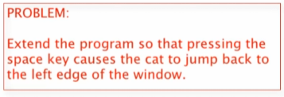

Change the domain analysis first:

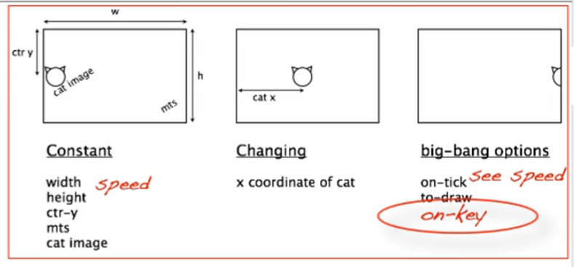

@big-bang function -> options

Go to design recipe -> HtDW -> get the template with the on-key event



Paste in the main function

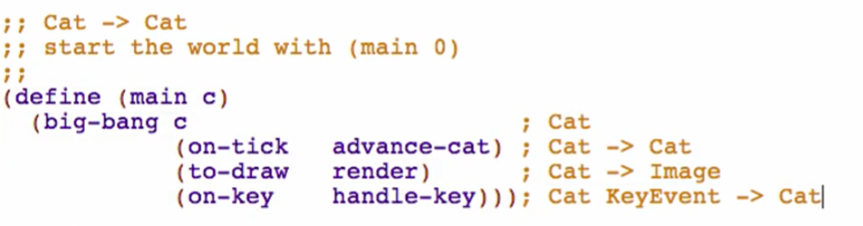

But we don’t have a handle-key function yet! We need to write down a wish list entry!

handle-key Function

**Signature** – from the signature of on-key on main function



**Purpose**



**Stub**

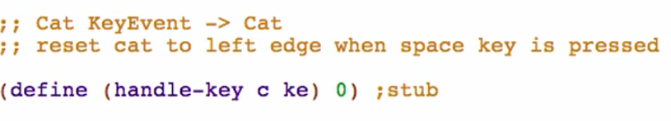

* 2 args
  + c as the x-coordinate of the cat
  + ke as the key that is pressed

**!!! –** add marker to tell that you are not yet finish in doing the function

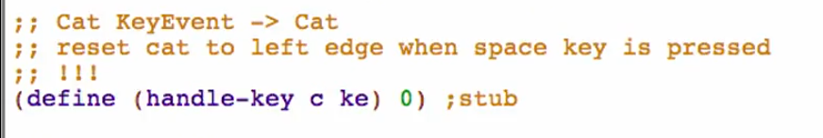

Fulfilling the wish list (handle-key)

**Examples**

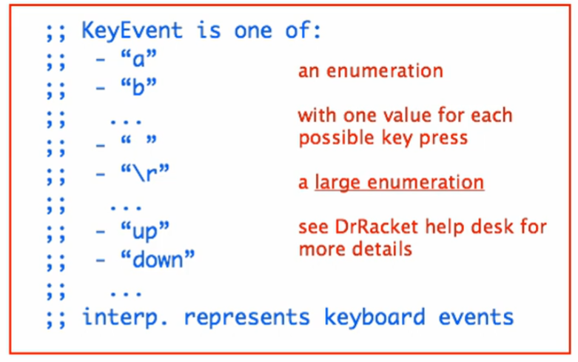

“ “ – space key

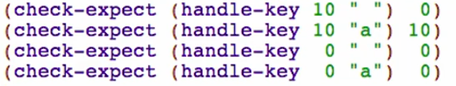

White-box testing

* for large-enumerations
* we will base the test on our knowledge of how the function is coded, not just what it is supposed to do

**Template**

Design Recipe -> HtDW -> Key and Mouse Handlers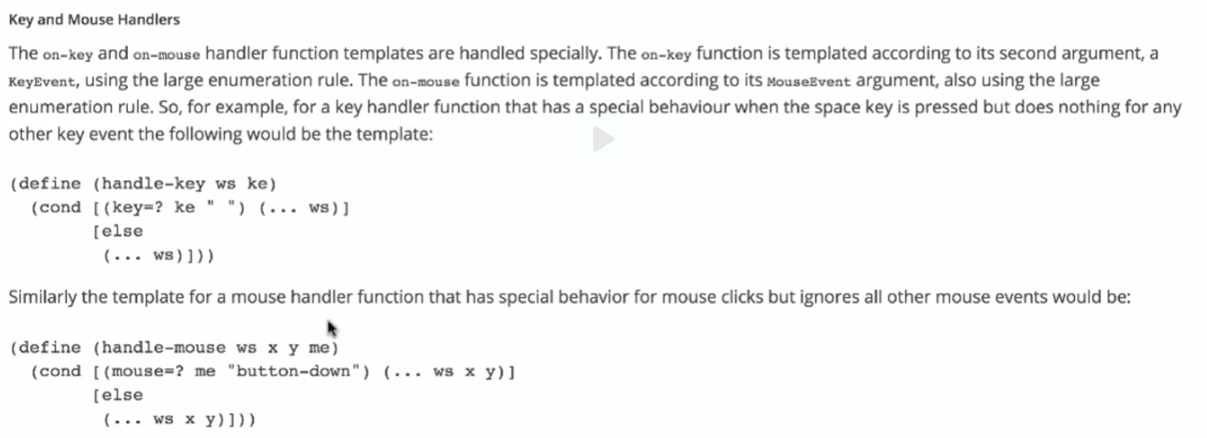

Comment out stub, copy the handle-key template, rename function name and param name based on your program

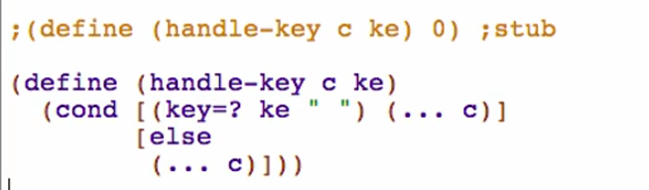

Normal rule for enumeration:

* produce a cond with very many cases

But with large enumerations:

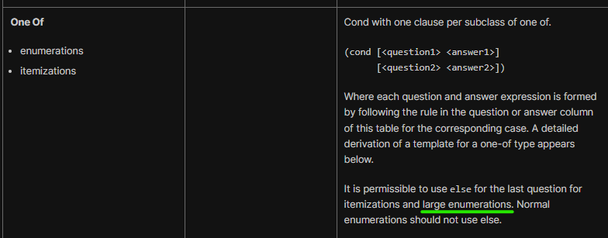

* we identify the special/particular cases first, write a (Q A) for it, and then else for others. (Like a default in switch case)

**Code Body**

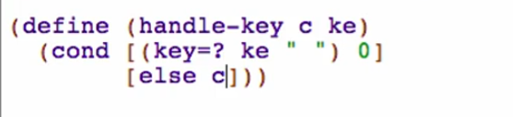

Run and test



Try calling main and press the spacebar

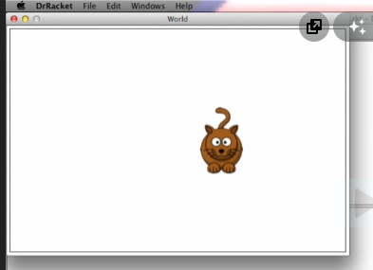 -> press space bar ->

